Part 1: Define your expression target

What molecule are you expressing?

The molecule I would be expressing is a set of pigment-producing enzymes that create colorful biological pigments. I would more specifically use violacein biosynthetic pathway to produce blue and purple pigments and carotenoid biosynthetic enzymes to produce yellow, orange, and red pigments. These pigments would create an abstract watercolor-like pattern within a Petri dish. Because I have a strong artistic background, I am interested in exploring biological systems as a creative platform for producing colorful abstract images.

2. What is the sequence?
The design will use genes from naturally occurring pigment pathways.

Violacein Pathway
Genes:
- vioA
- vioB
- vioC
- vioD
- vioE
Source:
- Chromobacterium violaceum
Database:
- NCBI Gene Database
- UniProt Database
Function: These genes encode enzymes that convert tryptophan into violacein, a purple-blue pigment.

Carotenoid Pathway
Genes:
- crtE
- crtB
- crtI
Source:
- Pantoea ananatis (formerly Erwinia uredovora)
Database:
- NCBI Gene Database
- UniProt Database
Function: These genes encode enzymes that produce carotenoid pigments responsible for yellow and orange coloration.
For the purposes of this design project, the gene sequences would be obtained from publicly available NCBI or UniProt entries and assembled into expression constructs suitable for the chosen host organism.
4. Where does the product need to go?

The pigments are intended to accumulate inside the bacterial cells.
Therefore:
Location: Cytoplasm
No secretion signal required
No membrane targeting sequence required
No specialized cellular compartment required

As the bacteria grow across the agar surface, intracellular pigments accumulate and become visible, creating regions of color that resemble the flowing appearance of watercolor paint.

Project Description (Updated Version)

My project involves engineering bacteria to produce colorful pigments that form an abstract watercolor-inspired design in a Petri dish. Instead of creating a portrait, the artwork will emphasize flowing colors, gradients, and organic textures similar to fluid painting. Different pigment-producing pathways will generate blue, purple, green, yellow, orange, and pink regions across the plate.

The project demonstrates how synthetic biology can be combined with artistic design to create living artwork. By controlling pigment production and spatial distribution of bacterial colonies, biological systems can be used as a medium for creative expression while also illustrating principles of genetic engineering and biomanufacturing.

Sources
- National Center for Biotechnology Information (NCBI) Gene Database
- UniProt Protein Database
- Synthetic Biology Open Language (SBOL) resources
- American Society for Microbiology (ASM)
- Initial project concepts and writing assistance generated with M365 Copilot (Microsoft, 2026)

Part 2: Design your genetic parts
Part 1: Promoter
Part Type

Promoter

Short Name

Constitutive Promoter

Sequence Source

Standard promoter part imported from the Asimov Kernel library (or another educational biological parts database).

Justification

A constitutive promoter continuously drives expression of pigment-producing genes, allowing coloration to develop throughout colony growth.

Part 2: Ribosome Binding Site
Part Type
RBS
Short Name
Medium-Strength RBS
Sequence Source
Standard E. coli ribosome binding site from the Kernel parts library.
Justification
The RBS enables efficient translation of the pigment pathway genes in the bacterial host.
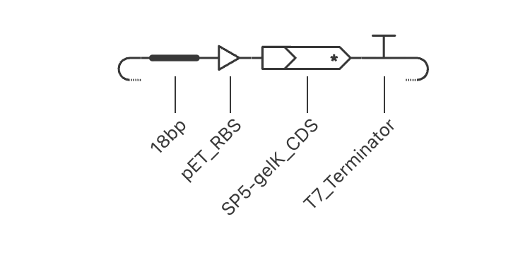

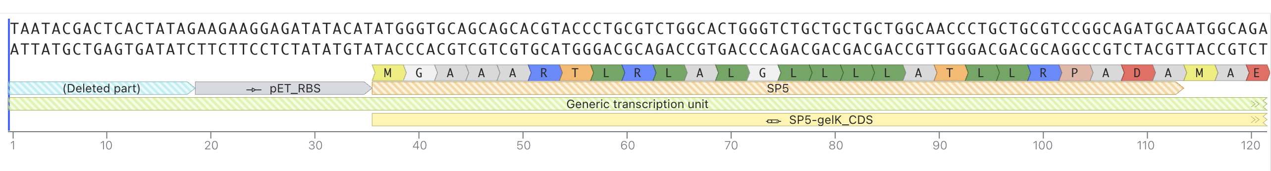

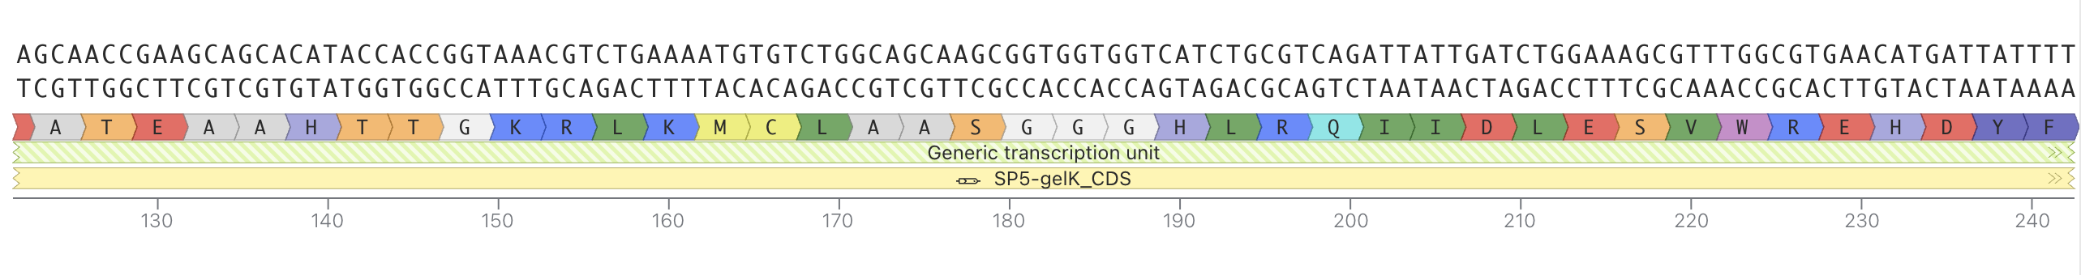
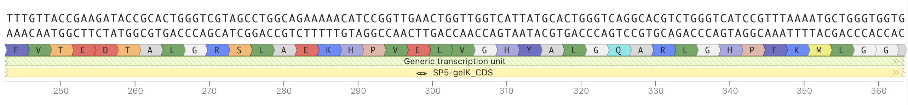

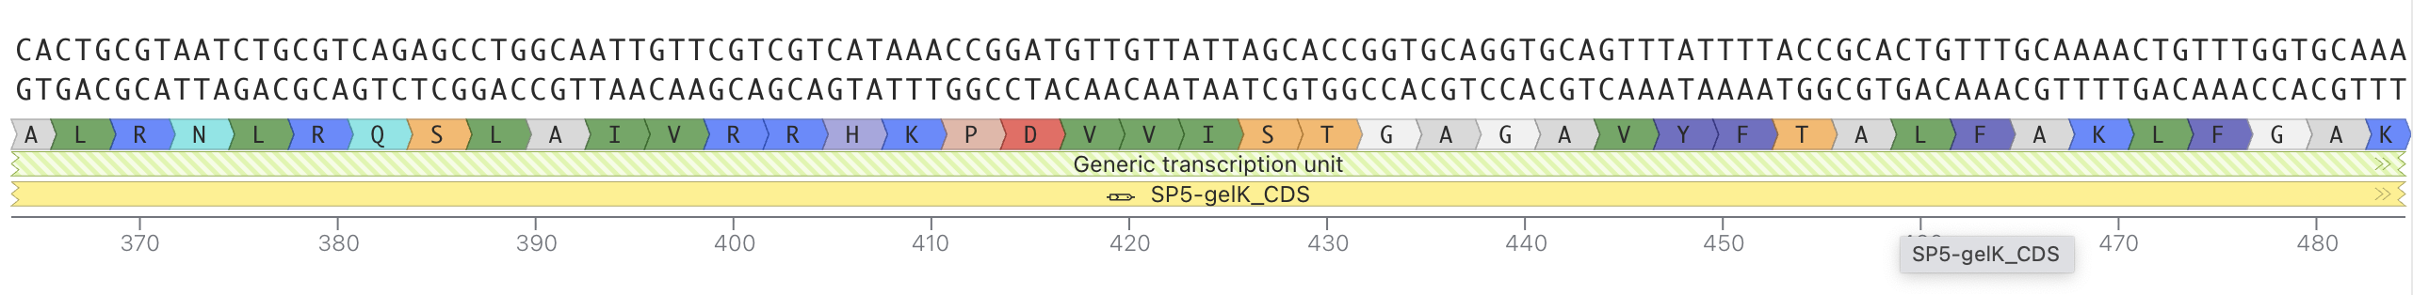

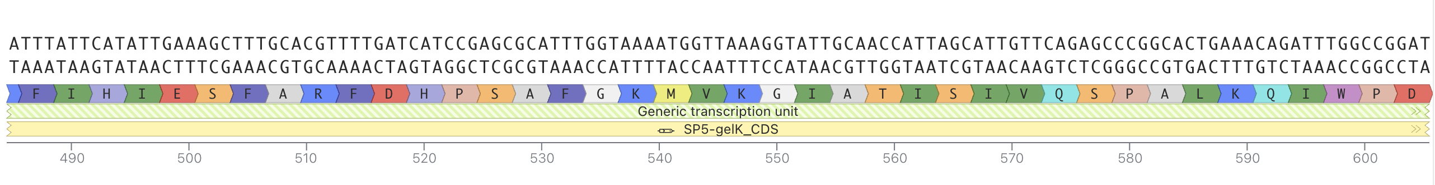

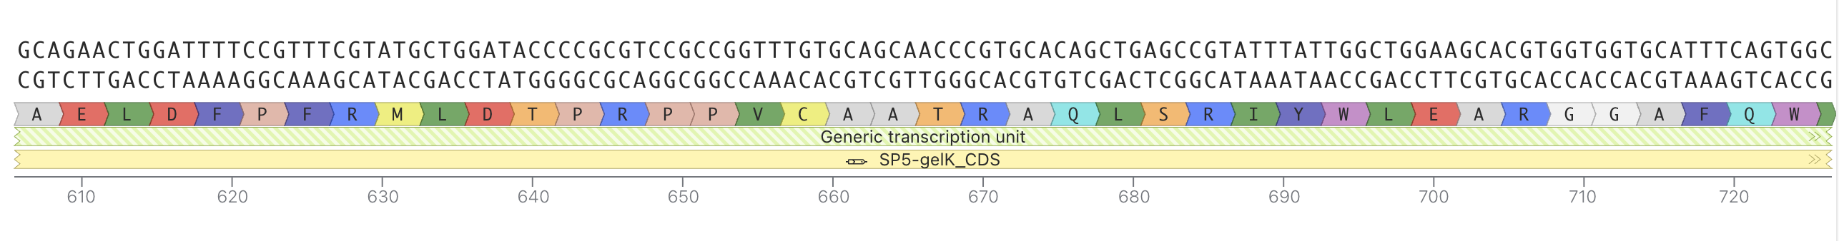

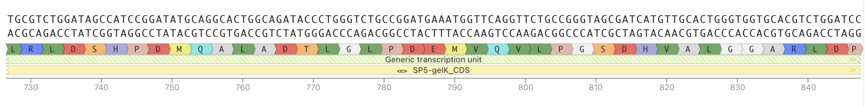

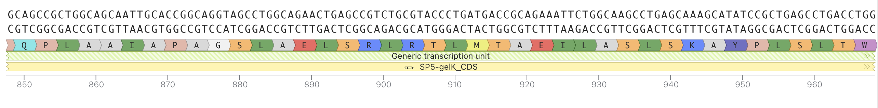

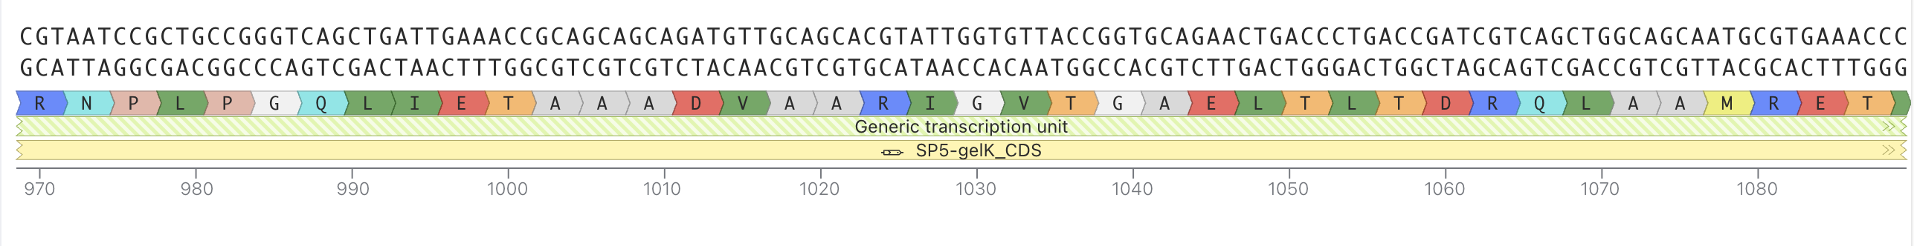
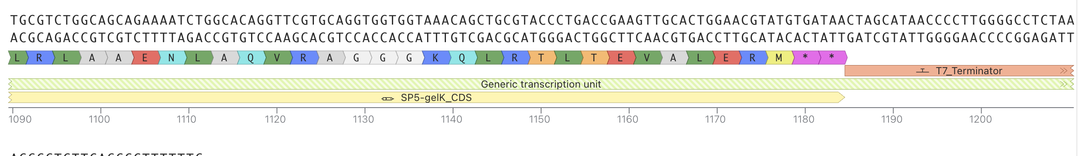

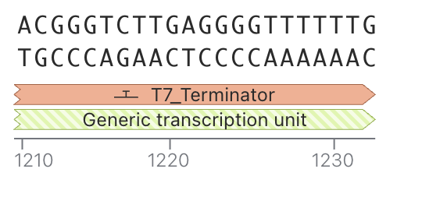

Part 3: Coding Sequence
Part Type

CDS

Short Name

Violacein Pigment Pathway

Sequence Source

Pigment biosynthesis genes identified from publicly available biological databases and imported into Kernel as reference biological parts.

Justification

The coding sequence produces enzymes that generate blue-purple pigments, matching the cooler color regions within the watercolor-inspired artwork.

Part Type

CDS

Short Name

Carotenoid Pigment Pathway

Sequence Source

Pigment pathway genes sourced from public biological sequence repositories and referenced in Kernel.

Justification

The carotenoid pathway produces yellow-orange colors that complement the blue-purple regions and help create the gradient appearance of watercolor art.

Part 4: Targeting Sequence
Part Type

Targeting Signal

Short Name

None Required

Sequence Source

Not applicable.

Justification

The pigments are intended to accumulate intracellularly, so secretion or membrane targeting is unnecessary.

Part 5: Terminator
Part Type

Terminator

Short Name

Bacterial Terminator

Sequence Source

Standard transcription terminator imported from the Kernel library.

Justification

The terminator provides a clear endpoint for transcription and helps ensure reliable expression of the pigment pathway.

Part 6: Backbone
Part Type

Vector Backbone

Short Name

Standard E. coli Expression Plasmid

Sequence Source

Existing educational plasmid backbone available within Kernel.

Components Provided
Origin of replication
Antibiotic selection marker
Cloning region
Justification

The backbone enables plasmid replication in E. coli and provides selection and maintenance of the construct.

The construct was assembled in Asimov Kernel using a promoter, ribosome binding site (RBS), coding sequence (CDS), and terminator arranged in the standard 5'→3' order for bacterial expression. The terminator was positioned downstream of the CDS to provide proper transcription termination. The construct map confirmed that all components were assembled in the intended orientation.

Part 4: Optimize and quality-check
Codon Optimization
I used Kernel's codon optimization tool on the coding sequence for the selected host organism. The purpose of codon optimization is to adjust synonymous codons so that the sequence better matches codon usage preferences of the host while preserving the encoded protein sequence. After optimization, the nucleotide sequence changed while the intended protein product remained the same. This type of optimization is commonly used to improve expression efficiency because different organisms preferentially use different codons. I reviewed the reported optimization metrics and confirmed that the optimized sequence remained consistent with the intended coding function.

Sequence Search / BLAST
I used Kernel's sequence search tool to compare the coding sequence against known biological sequences. The purpose of this analysis is to determine whether the sequence matches known genes and to identify related sequences. The results indicated that the sequence was most similar to previously characterized sequences in public databases. Based on the search results, I concluded that the coding sequence corresponds to the expected gene rather than representing a completely novel sequence. The sequence search provided additional confidence that the construct contains the intended coding region.

Safety Screen
I ran Kernel's safety screening tool on the construct. The purpose of the safety screen is to identify features that may require additional review, such as sequences associated with regulatory concerns, sequence anomalies, or other factors defined by the screening framework. I reviewed the reported results and noted whether any flags were generated. If a flag appears, it does not necessarily indicate a problem; rather, it indicates that the sequence should be reviewed in the context of the project goals and applicable safety requirements. The safety screen serves as a quality-control step to support responsible design practices.

Part 5: From design to build
How would you build it?
If this construct were developed beyond the in silico stage, I would obtain the DNA as commercially synthesized DNA rather than attempting to create the entire sequence manually. Modern DNA synthesis providers can produce custom DNA fragments based on a computer-designed sequence, which can then be incorporated into larger constructs. For more complex designs containing multiple genetic elements, researchers often assemble several DNA fragments into a single construct using DNA assembly approaches. DNA assembly methods such as Gibson Assembly are widely used because they allow multiple DNA fragments to be joined into a larger construct.

For my pigment-producing construct, the design is conceptually moderate in complexity because it contains several standard genetic components, including a promoter, ribosome binding site, coding sequence, and terminator. Therefore, synthesized DNA fragments combined into a larger construct would be a reasonable approach.
2. What does synthesis constrain?

DNA synthesis is not perfect, and certain sequence characteristics can make synthesis more difficult. Published research notes that repetitive DNA sequences can cause synthesis failures or delays and may require alternative assembly strategies. DNA sequences with strong secondary structure or unusually high GC content can also present challenges during DNA synthesis and downstream analysis.

My construct is primarily composed of standard expression elements and is not intentionally designed around long repetitive regions. However, any synthesized DNA could still contain errors introduced during synthesis. Because synthesis technologies are not error-free, quality-control and sequence verification steps are important before further work is performed. Some DNA synthesis providers specifically emphasize low error rates and sequence quality as key performance metrics.

As a result, the design process would need to account for the limitations of DNA synthesis technologies and incorporate appropriate verification of the final sequence.

3. Prototype vs. Scale

The prototype stage and large-scale production stage would likely differ. During the prototype phase, the goal would be to determine whether the genetic design successfully produces the intended pigment pattern and visual appearance. Only a small number of DNA constructs would be needed for evaluating the design concept.

At larger scales, the emphasis would shift toward reproducibility, quality control, cost, and consistency across many copies of the construct. The same underlying design might be used, but DNA manufacturing processes would need to ensure reliable production and verification of the final product. This distinction mirrors broader biomanufacturing workflows, where early prototypes are used to test an idea and later manufacturing focuses on scalability and standardization.

Sources
Addgene. "Gibson Assembly Protocol."
New England Biolabs (NEB). "Gibson Assembly Protocol."
Nguyen et al., ACS Synthetic Biology (2024), discussion of synthesis challenges associated with repetitive sequences.

Part 6: What Don't You Know Yet?

Unknown #1: Will the coding sequence produce the desired level of pigment expression?

One uncertainty is whether the selected promoter and ribosome binding site will produce the appropriate amount of protein. Expression that is too low may result in weak coloration, while expression that is too high could place a burden on the host cells or alter the appearance of the final artwork.

To investigate this, I would compare construct variants containing different promoter or expression-strength elements and measure visible pigment production. The results would help determine whether additional tuning of gene expression is necessary.

Unknown #2: Will the pigment pathway function as expected in the chosen host?

Although the coding sequence is intended to produce pigment, there is uncertainty regarding how effectively the pathway functions in the host organism. A gene that performs well in one organism may not behave identically in another due to differences in cellular processes and resource availability.

I would evaluate this by comparing the observed pigment phenotype against the expected outcome and assessing whether coloration develops as intended. If pigment production is weaker than expected, additional construct variants or design modifications could be evaluated.

Unknown #3: Will the final microbial artwork produce the intended visual pattern?

The goal of this project is not only biological expression but also artistic appearance. Even if pigment production is successful, the final plate may not resemble the watercolor-inspired design because colony growth patterns can vary across the surface of the agar.

To investigate this uncertainty, I would create several design iterations and compare their visual appearance. Imaging and documentation of the resulting patterns would help determine whether the design creates the desired gradients, color transitions, and abstract watercolor effect.

Conclusion

The largest uncertainties in this design involve expression level, pigment production performance, and the final visual appearance of the artwork. These factors cannot be fully predicted from an in silico design alone and would require iterative testing and evaluation. The next design cycle would focus on comparing construct variants, assessing pigment production, and determining whether the resulting microbial art matches the intended watercolor-inspired aesthetic.

Sources
- Addgene. "Gibson Assembly Protocol." Discusses DNA construct assembly and the importance of testing and validating engineered genetic designs. [addgene.org]
- New England Biolabs (NEB). "Gibson Assembly Protocol." Notes that assembly efficiency can vary with fragment number and design complexity, highlighting the need for experimental validation of constructs. [neb.com]
- Nguyen et al. "Enzymatic Assembly of Small Synthetic Genes with Repetitive Elements," ACS Synthetic Biology (2024). Describes how sequence design can introduce challenges that require iteration and testing. [pmc.ncbi.nlm.nih.gov], [ncbi.nlm.nih.gov]
- GenCefe Biotech. "Gene Synthesis Strategies for Difficult DNA Sequences." Reviews common uncertainties in gene synthesis, including high GC content, repetitive sequences, and secondary structure formation. [gencefebio.com]

